##### Costume Information

Please return by November 30,2022!

Krewe Member’s Name: ____________________________________________

*~ or ~*

Escort’s Full Name: ___________________________________________________________

Shirt size: _________________

Coat size: _________________

Pants: Length _________________

Waist _________________

Note: These measurements are used to determine whether costume ordered will be S, M, L, XL or XXL.

**Please Email completed Costume Form to** [**Captain@KreweofEROS.com**](mailto:Captain@KreweofEROS.com)

##### Supper Dance Tickets Order Form

Please return no later than November 30, 2022.

Court fees include tickets for the Court Member and Escort (when applicable). Please complete the section below for any additional Supper Dance tickets that you may need for your guests and remit along with payment. Please contact me if you have any questions or need any additional information.

***\*\*\*Please make checks payable to: The Maskers’ Club\*\*\****

# of Supper Dance tickets needed ______________

Cost per ticket $110.00

Total Due $______________

Please also reserve a table (seats 10) in my name, _______________________________.

I do not need a reserved table; I will be sitting at the _____________________________ table.

**Please Email completed Supper Dance Ticket Form to** [**Captain@KreweofEROS.com**](mailto:Captain@KreweofEROS.com)

##### Favor Order Form

***Deadline for ordering Favors is November 30, 2022***

***.***

***Quantities are limited, so please pre-order NOW!!!***

***Pre-ordered favors are distributed at Krewe Rehearsal, which is on Monday, January 9, 2023.***

***\*\*\*Please make checks payable to: The Maskers’ Club \*\*\****

Member’s Name/Position: _________________________________________

Please reserve for me _________ (quantity) favors @ $40.00 each.

Total Due: ______________

**EROS – “Love is in the Air”**

**By Adler’s**

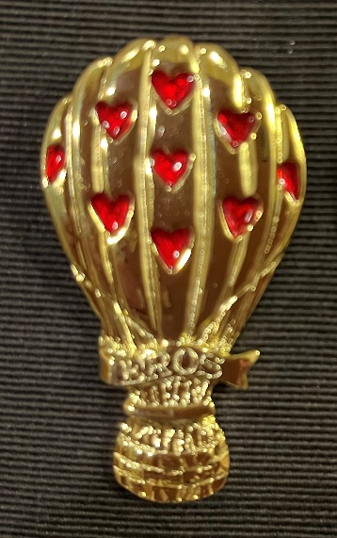

The Official 2023 Krewe of Eros Krewe favor is gold plated and accented with red hearts.

**Please Email the completed Favor Order Form to** [**Captain@KreweofEROS.com**](mailto:Captain@KreweofEROS.com)